1. **A Proposed Database Solution for Morning Nosh Cereal Co.’s HR Department**

**Group 1**

Project Manager: Vikki Hirschey [hirschv01@buffalostate.edu](mailto:hirschv01@buffalostate.edu)

Database Architect: Joseph Idowu [Idowujb01@buffalostate.edu](mailto:Idowujb01@buffalostate.edu)

Systems Analyst: Jordan Piershalski [piershjs01@buffalostate.edu](mailto:piershjs01@buffalostate.edu)

Application Developer: Vladyslav Varian [varianv01@buffalostate.edu](mailto:varianv01@buffalostate.edu)

Documentation Writer: Ava Hintz [hintza01@buffalostate.edu](mailto:hintza01@buffalostate.edu)

QA Tester: Todd Nelson, [nelsonte01@buffalostate.edu](mailto:nelsonte01@buffalostate.edu)

1. **Narrative Description**

**Our Company Name:** Buffalo IT Consulting, LLC.

Within this document and attached files, the Authors propose a comprehensive database solution tailored for a Human Resources (HR) department within a cereal company. The primary users of this system are HR managers and HR generalists, and the stakeholders include the 300 employees distributed across the company's five departments: Software Development, Systems Administration, Product Management, Quality Assurance, and IT Support. Positions within these departments vary, with compensation structures ranging from salaried to hourly, and the benefit packages differ based on the role.

The company feels there is an opportunity to create a centralized, secure, and efficient system that simplifies HR tasks, which has led them to seek the aid of Buffalo IT Consulting, LLC. The current system necessitates an immense amount of manual processing, leading to errors and delays when the company’s HR generalists attempt to alter or retrieve employee data within the system. The system also lacks the capacity to store data related to employee performance reviews which have only been physically recorded with paper and pencil.

The company’s HR department serves as the central repository for a broad spectrum of employee information. This ranges from basic details such as names and birth dates to more sensitive records like social security numbers and medical benefit plans. The proposed system is designed to alleviate the bottlenecks in the current setup by reducing manual data processing, minimizing errors, and expediting the retrieval of information. Additionally, it introduces the much-needed feature of digitally storing performance reviews. Further enhancing its utility, the system is architecturally designed to integrate seamlessly with the company’s existing database infrastructure

Regarding compliance, the proposed solution adheres to stringent legal frameworks, specifically the Health Insurance Portability and Accountability Act (HIPAA) and New York's SHIELD Act. These laws mandate robust encryption, restricted access controls, and comprehensive logs for all activities involving sensitive data. In summary, the proposed HR database solution offers both operational efficiency and legal compliance, profoundly increasing and improving the company's human resources management capabilities.

**Company Name for the Database:** Morning Nosh Cereal Co.

**Employees:** 100 (to start)

**Jobs:** Production Workers/Operator, Quality Control Inspectors, Machine Operators, Packaging Operators, Maintenance Technicians, Warehouse Workers, Food Scientists/Food Technologists, Quality Assurance Specialists, Logistics and Distribution Personnel, Sanitation Workers, Supervisors and Managers, Research and Development (R&D) Specialists

1. **Identification of Information Needs**

Entities used for this project will be hand made as of now. If a reliable database will be found that will supply us with all of the required entities without our need to manually create them, we will use that.

1. **List Of Entities**

Employees

Department

Position

Attendance Performance Review

1. **Distribution of Duties**

*Project Manager: Vikki Hirschey*

*Database Architect: Joseph Idowu*

*Systems Analyst: Jordan Piershalski*

*Application Developer: Vladyslav Varian*

*Documentation Writer: Ava Hintz*

*QA Tester: Todd Nelson*

### 1. Employees

* EmployeeID (Primary Key): Unique identifier for each employee
* FirstName: First name of the employee
* LastName: Last name of the employee
* DateOfBirth: Employee's date of birth
* DateOfJoining: Employee's joining date
* PositionID (Foreign Key): Reference to the Position table
* DepartmentID (Foreign Key): Reference to the Department table
* Email: Employee's email address

This table stores basic information about each employee.

### 2. Department

* DepartmentID (Primary Key): Unique identifier for each department
* DepartmentName: Name of the department
* ManagerID (Foreign Key): Reference to the Employee who manages the department

This table describes the various departments within the company.

### 3. Position

* PositionID (Primary Key): Unique identifier for each position/title
* PositionTitle: Title of the position (e.g., Software Engineer, HR Manager)
* Salary: Basic salary for the position
* JobDescription: A brief description of the job responsibilities

This table outlines different positions or titles within the company along with their basic salary and job description.

### 4. Attendance

* AttendanceID (Primary Key): Unique identifier for each attendance record
* EmployeeID (Foreign Key): Reference to the Employee
* Date: The date of the attendance
* Status: Marked as 'Present', 'Absent', or 'Leave'

This table keeps track of employee attendance.

### 5. PerformanceReview

* ReviewID (Primary Key): Unique identifier for each review record
* EmployeeID (Foreign Key): Reference to the Employee
* ReviewDate: The date the review was conducted
* PerformanceRating: Rating assigned during the review (e.g., Excellent, Good, Average)
* Comments: Additional comments from the reviewer

This table stores performance reviews for employees.

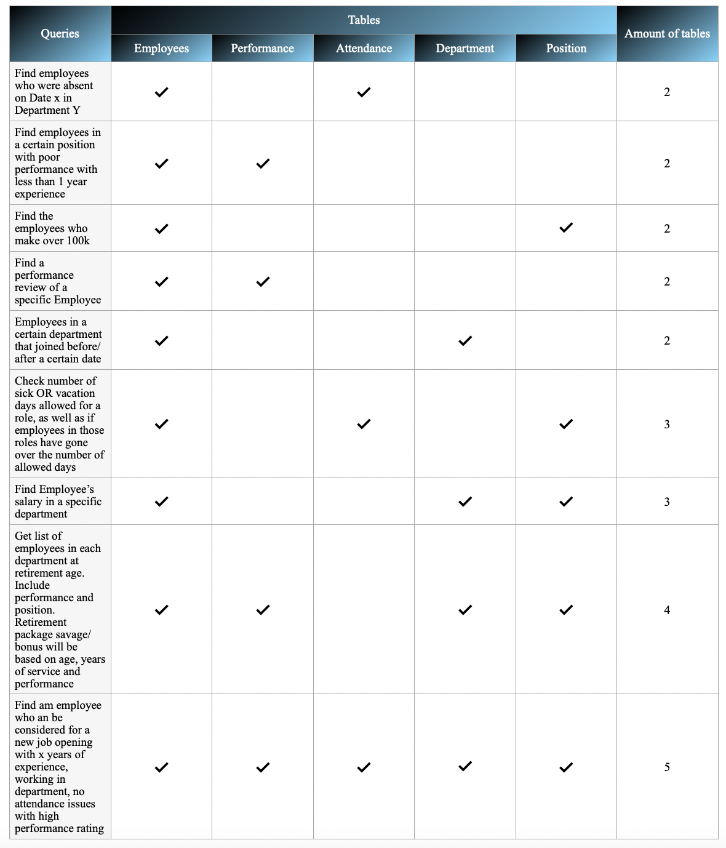

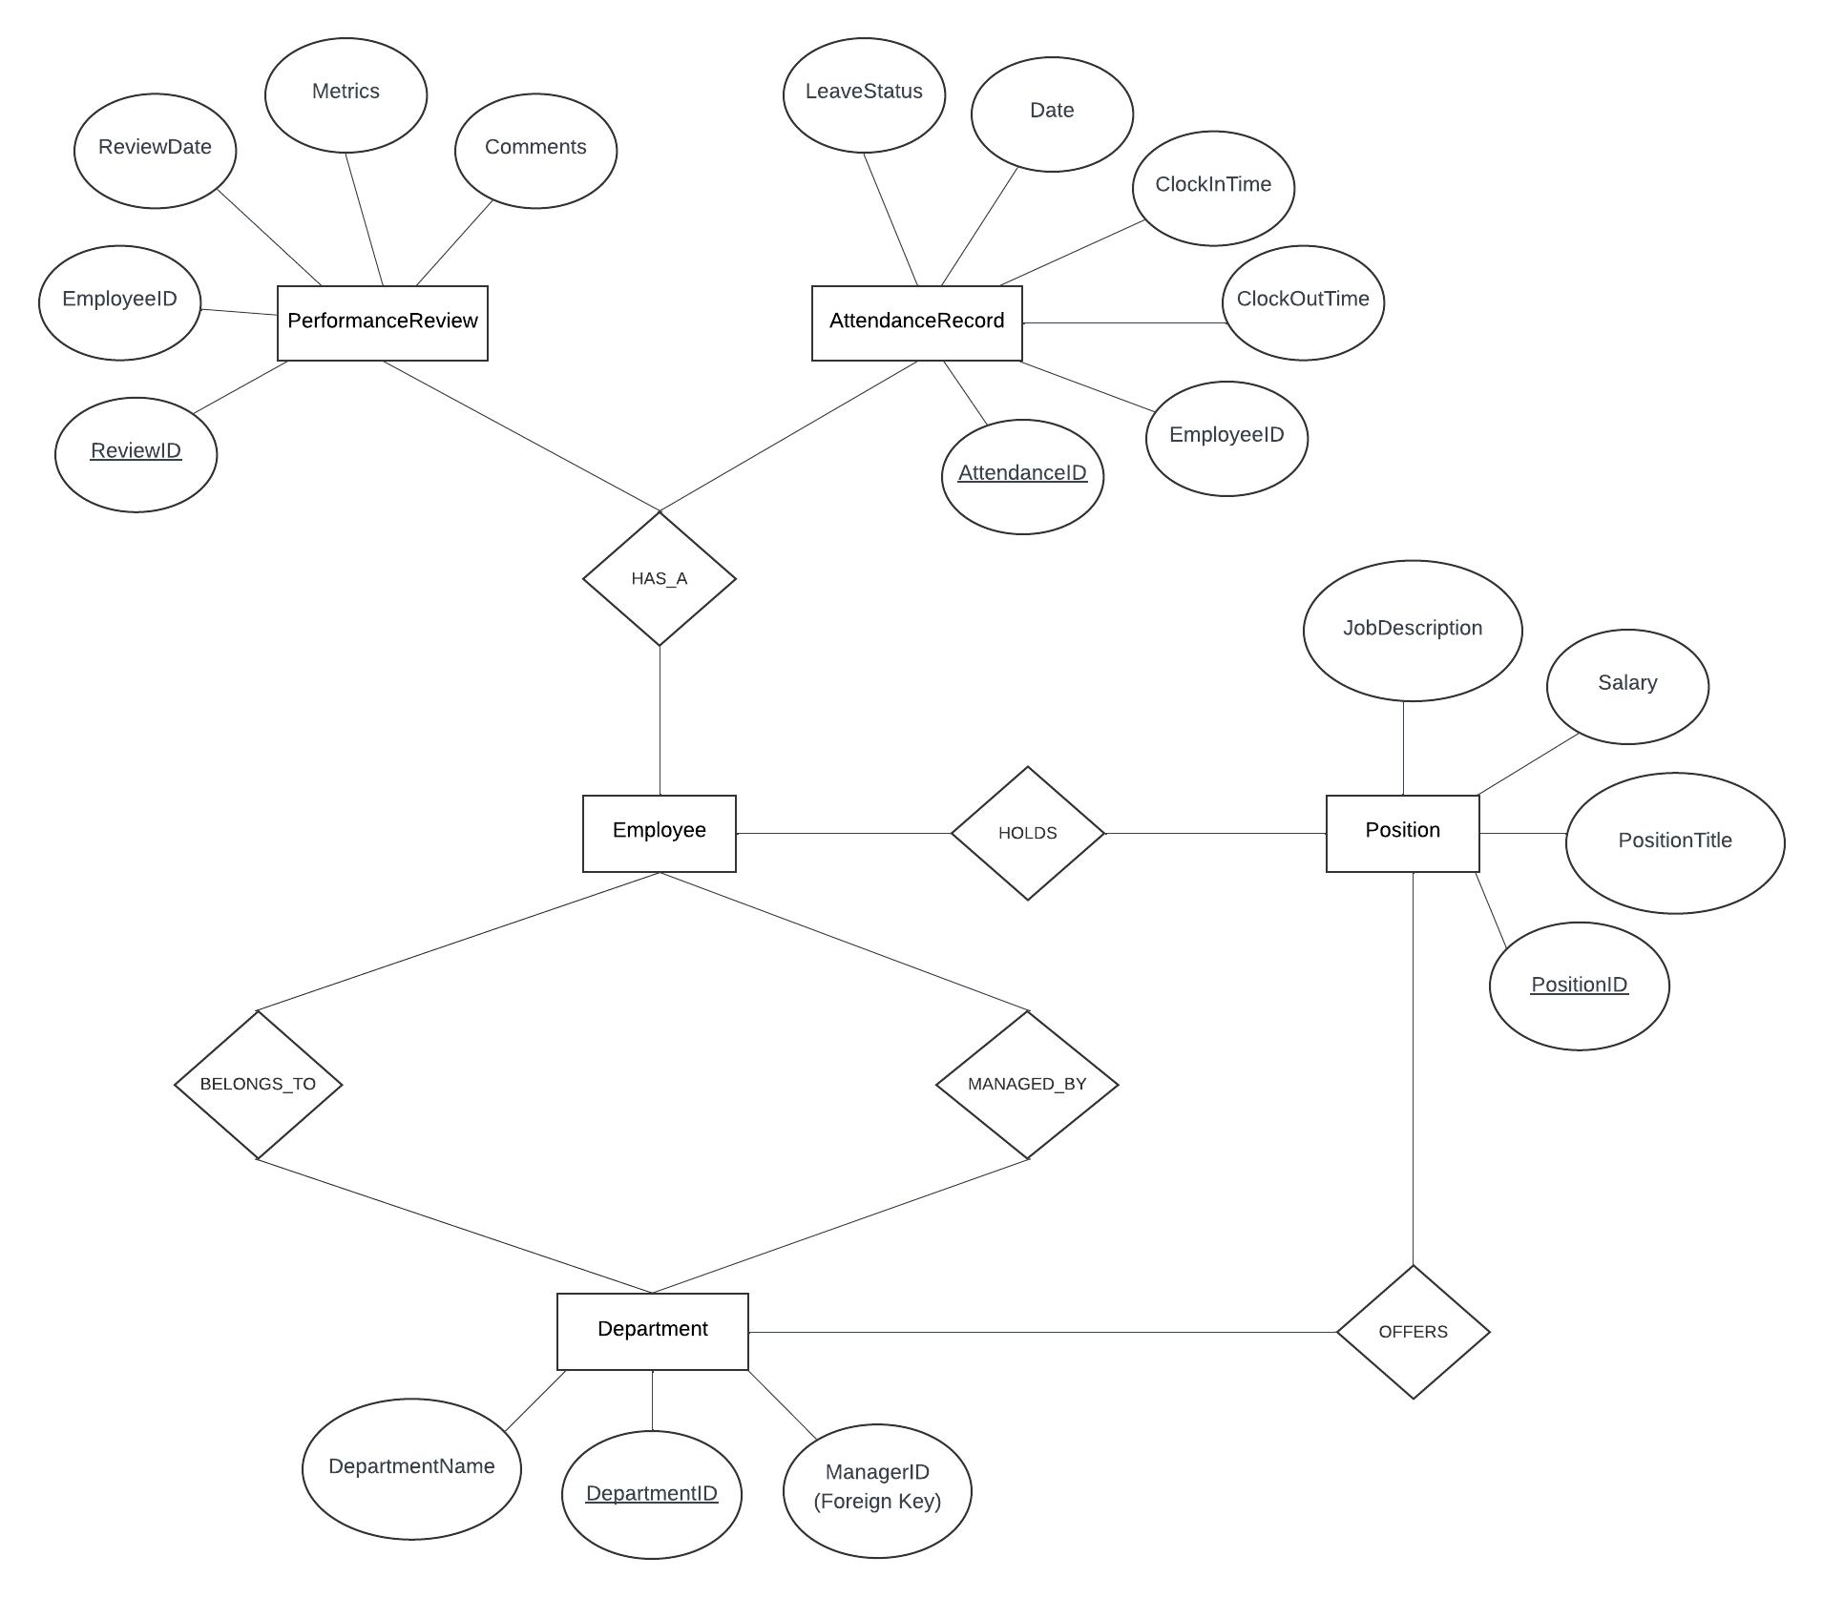

**E-R Diagram, (2023); Lucidchart.com**

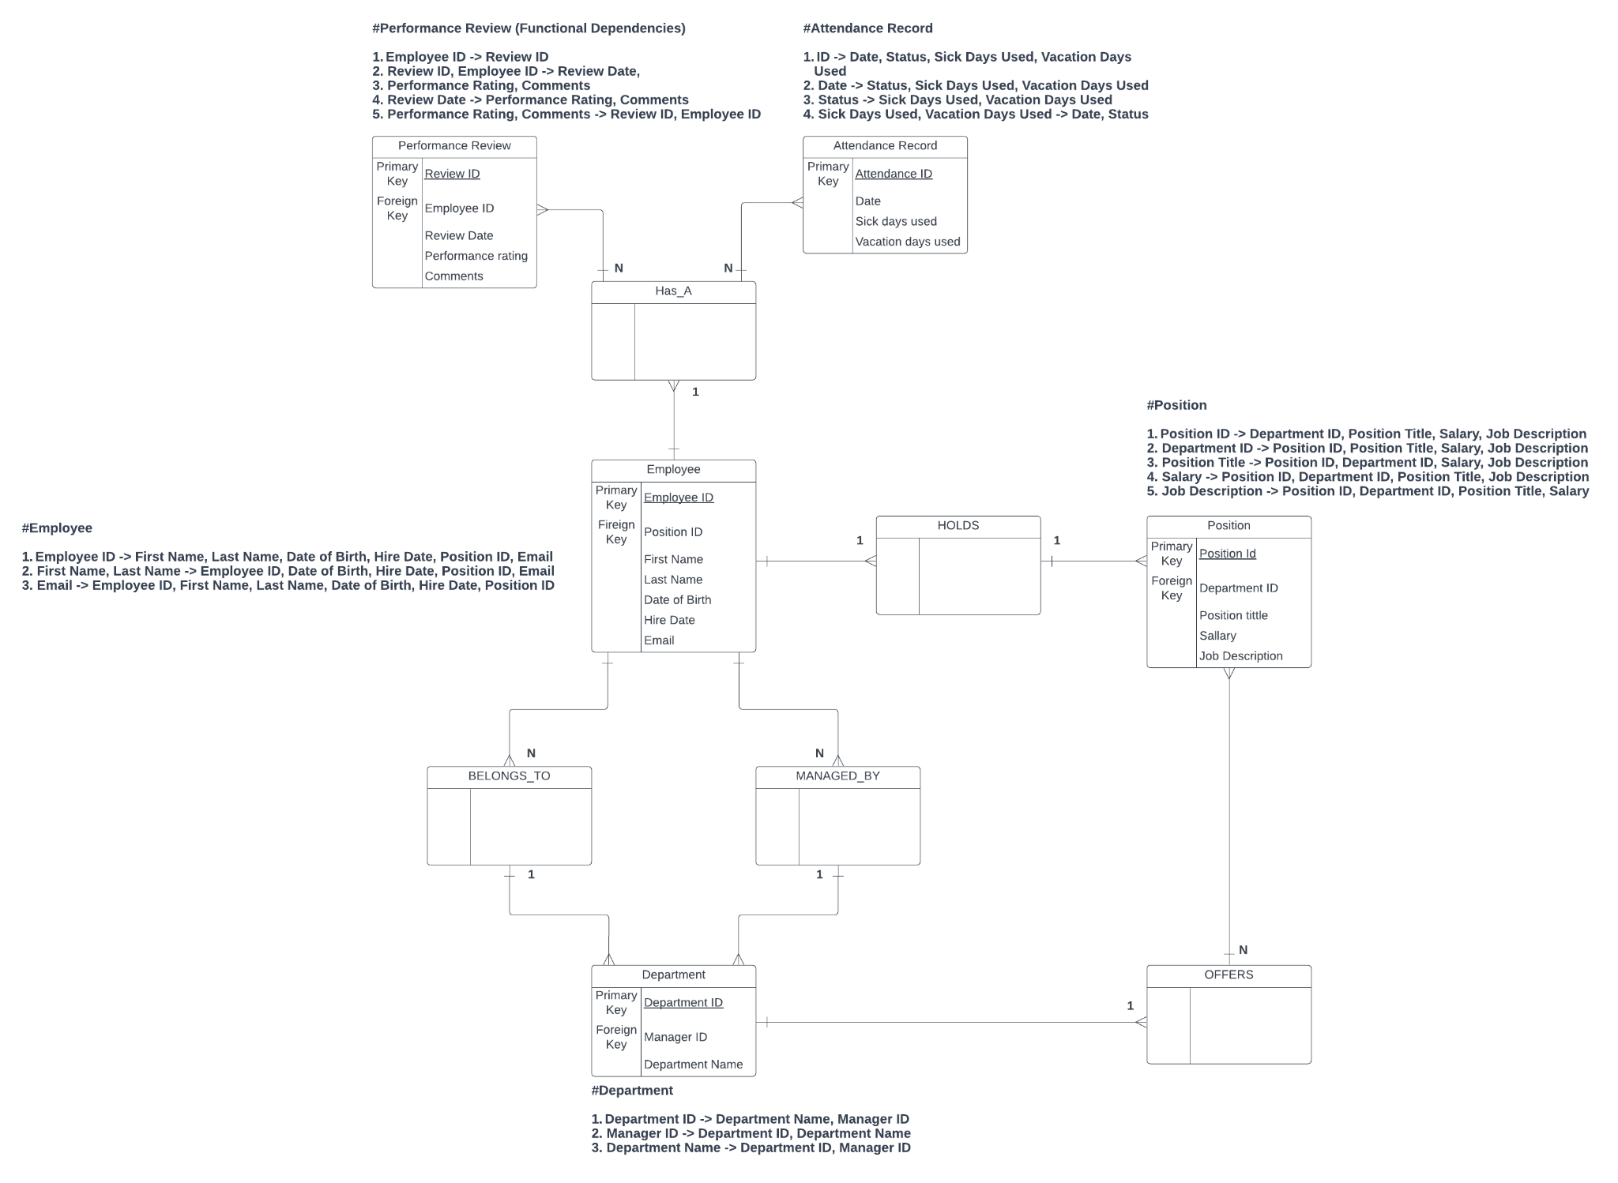

**Relational Model Diagram “with dependencies”, (2023); Lucidchart.com**

**Final Report**

A formal report and presentation are required. This report should include:

1. A separate cover page indicating the GROUP Number, the title of your project, the full names of the group members (with e-mail). (**DONE**)

2. An introduction section similar to the proposal. (**We have a narrative, does that count or does it have to be something else**?)

3. Entity Relationship Model diagram. (**DONE**)

4. The collection of normalized relations and functional dependencies, and a brief

discussion as to the normal form(s) achieved, the methods used to achieve these

normal forms, and reasons why any de-normalization was done.

(**I think this part is half way done and we need to discuss this together ideally**)

5. The SQL DDL used to create the tables and add primary key and foreign key

constraints. (**Ignore SQL stuff**)

6. An example printout of each of the forms, reports and queries accompanied by a

description of the function of each. (**Need pictures from the Access database file to be put on Powerpoint presentation**)

7. A picture of the Navigation form showing the organization of the different Forms

and reports in the application. (**Yet to be done I think**)

8. Peer evaluation.(**This can be done individually and saved as a separate file, not sure how we are supposed to format the peer review file.**)